***Supplementary Information***

Electrically driven on-chip transferrable micro-LEDs

*Byung-Ju Min1†, Yeon-Ji Kim1†, Jae-Hyuck Choi2†, Min-Woo Kim1, Kyong-Tae Park1, Dong Jin Jang1, Jin Sik Choi1 and You-Shin No1,a)*

*1* Department of Physics, Konkuk University, Seoul 05029, Republic of Korea

2 Space Optics Team, Advanced Instrumentation Institute, Korea Research Institute of Standards and Science, 267, Gajeong-ro, Yuseong-gu, Daejeon 34113, South Korea

a) Author to whom correspondence should be addressed: E-mail: ysno@konkuk.ac.kr

**This file includes:**

Supplementary Information Figures S1–S6

**Supplementary Information Figures**



**FIG. S1.** Details of compositional materials, doping concentrations, and dimensions of the AlGaInP/GaAs LED epitaxial wafer. High levels of doping concentrations of ~1019 and ~1018 were applied to the *p*-contact GaAs and *n*-contact GaInP layer, respectively. The AlGaInP spacer with a lower doping concentration of ~1017 serves as an intermediate conducting layer to help the smooth injections of carriers.

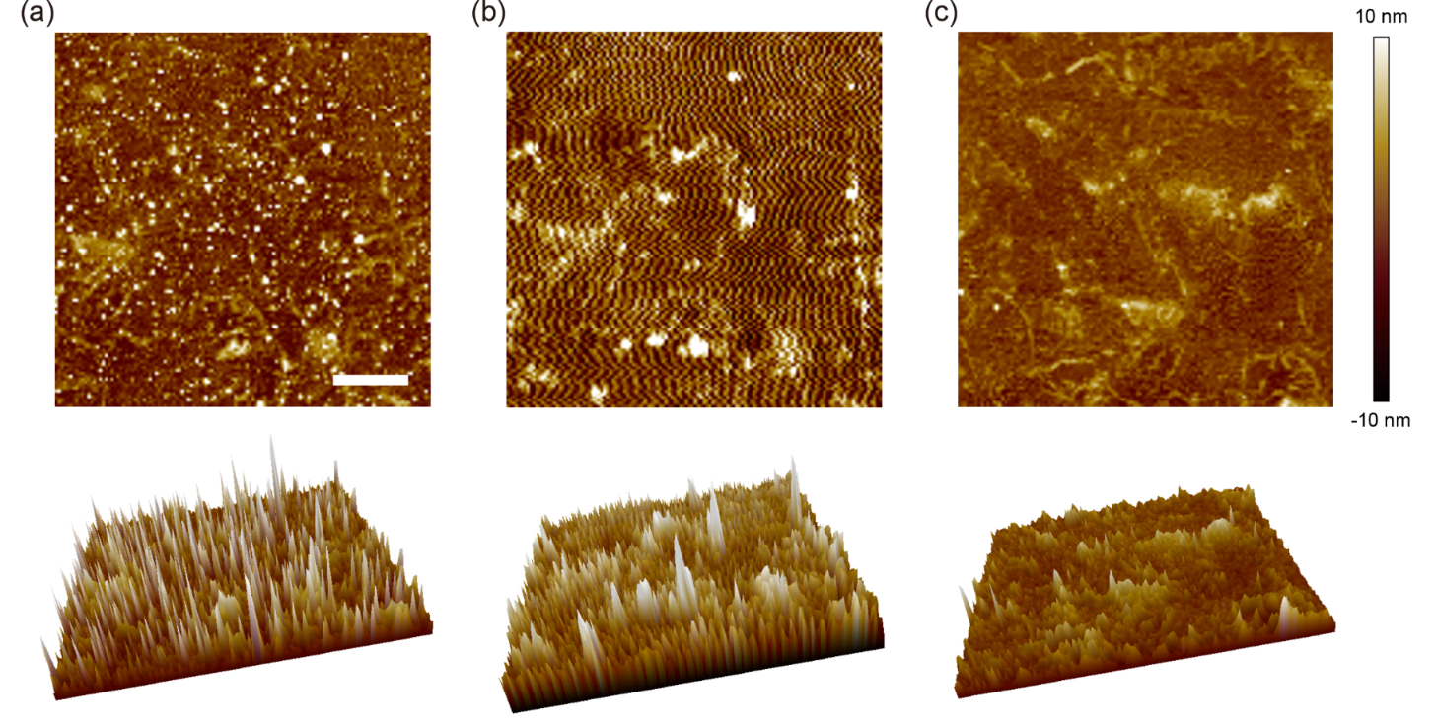

**FIG. S2.** Atomic force microscopy (AFM) topographic characterization of graphene-contact. (a) Two- (top) and three-dimensional (bottom) topographic plots of an area of 5 µm × 5 µm for the wet-transferred multi-layered graphene (MLG) on SiO2. Scale bar: 1 µm. (b) Topographic plots of the same area of (a) after applying a uniform and local pressure for 30 min using single microdisk attached to the bottom surface of PDMS microtip. (c) Topographic plots after processing the rapid thermal annealing (RTA) at 300 ℃ for three hours. The graphene surface after applying the pressure and RTA shows progressively more uniformly structured surfaces than that of pre-loaded graphene surface. As a result, it forms a uniform graphene/microdisk bottom contact. The root-mean-square (rms) roughness was measured as 2.982, 3.794, and 1.576 nm for the surfaces of (a), (b) and (c), respectively.



**FIG. S3.** Transmission line method (TLM) experiment. (a)-(b) Cross sectional schematic (i) and tilt-view SEM image (ii) of the TLM devices: (a) PMMA/MLG/Au and (b) PMMA/MLG/*p*-AlGaInP structures. (a) The PMMA/MLG sheet was wet-transferred on the pre-fabricated metal electrodes followed by electron-beam (E-beam) lithography to define the MLG channels. (b) The vertically *p*-*i*-*n* doped AlGaInP slab structure with size of 24.8 µm × 3.0 µm × 0.2 µm was fabricated and micro-transferred on SiO2 substrate. The PMMA/MLG sheet was then wet-transferred on top of the *p*-AlGaInP layer and went through the E-beam lithography to define the channels. The channel width for both devices was 3 µm. Scale bars: 5 µm. (c) TLM results for PMMA/MLG/Au (i) and PMMA/MLG/*p*-AlGaInP structures (ii). The resistances were measured as a function of the channel length at 298 K. The black dotted lines are linear fits to the measured data points (black dots). (d) Contact resistivities (*ρc*) under different temperatures. The table shows the contact resistivities for both devices in (a) and (b) at temperatures of 298, 340 and 380 K. The result reveals clear interfacial improvements on both devices, exhibiting the reduced *ρc* with temperature. In a separate experiment, we measured the contact resistivity of *n*-AlGaInP/MLG/SiO2 structure as ~ 9.9×10-4 Ω·cm2 at room temperature.



**FIG S4.** Temperature-dependent electrical transport properties. Measured *I*-*V* curves plotted as a function of temperature. The fabricated device was put in a temperature-controlled chamber. As the temperature increased, the contact resistivity exhibited improvements, resulting in the reduced total resistance of the device (*R*total), which showed an inversely proportional behavior. These observations are consistent with the results from the previous reports1-4.



**FIG. S5.** The side-wall contact of top graphene and the development of emission profiles with pump current (*I*pump). (a) Low- (i) and high-magnification (ii) SEM images of the device in Fig. 2. Tilt-view images show the microdisk boundary where the top graphene/PMMA layer was contacted on the upper part of side-wall. Scale bar: 2 µm and 400 nm. (b)–(c) Captured CCD images showing the emission profiles at different levels of *I*pump. (b) For low *I*pump < 10 µA, the EL emissions exhibited a uniformly distributed circular pattern at the central area of microdisk. Scale bar: 2 µm. (c) For high *I*pump > 10 µA, a localized light spot at the boundary of microdisk increased in its intensity and became a strong and dominant emission spot.



**FIG. S6.** Micro-LED device with central emission patterns at high current levels. (a) Measured *I*-*V* curve showing diode-like characteristics. Inset: SEM image of the fabricated device. Scale bar: 2 µm. Turn-on voltage and device resistance were 6.2 V and 20.1 kΩ, respectively. (b) Captured CCD images of the emission profiles at various current levels. The circular emission pattern at the center of microdisk was unchanged for all the current levels ranging from ~6.7 to ~89.8 µA. This uniform emission pattern experimentally reassure that the carrier recombination primarily occurs where the disk-shaped top graphene pattern was defined. Scale bar: 2 µm.

**References**

1S. E. Swirhun and R. M. Swanson, IEEE Electron Device Lett. **7**, 155 (1986).

2J. S. Kwak, O. Nam, and Y. Park, J. Appl. Phys. **95**, 5917 (2004).

3N. C. Chen, Y. K. Yang, W. C. Lien, and C. Y. Tseng, J. Appl. Phys. **102**, 4370 (2007).

4Z. Khurelbaatar, Y.-H. Kil, K.-H. Shim, H. Cho, M.-J. Kim, Y.-T. Kim, and C.-J. Choi, J. Semicond. Technol. Sci. **15**, 7 (2015).